**Instructions to deploy the Project on a local system using Windows.**

1. **Download the project folder for local deployment**: Ensure you have the project folder downloaded and accessible on your local machine.
2. **Adding your OPENAI_API_KEY and FLASH_SECRET_KEY:**

* Open the .env file using a text editor.
* Add your OpenAI API key in the following format: OPENAI_API_KEY=”YOUR_API_KEY”
* FLASH_SECRET_KEY=“SUPER_SECRET_KEY”
* Save and close the .env file.

1. **Install Python:**

* If you don't already have Python installed on your system, download and install it from the official Python website: [Python Downloads](https://www.python.org/downloads/).
* During installation, make sure to check the option to add Python to your system's PATH. This will allow you to run Python commands from the command line.

1. **Install project dependencies**:

* Open a terminal or command prompt.
* Navigate to the project folder using the cd command.
* Once inside the project folder, install the required Python packages listed in the requirements.txt file using pip. Run the following command:

pip install -r requirements.txt

1. Add yourself to these folders with the formant name#1234 :
   * education-website\chapter-quiz\entrance-exam\list-of-people
   * education-website\chapter-quiz\quiz1\feedback
   * education-website\chapter-quiz\quiz2\feedback <= this one will work but it not ready yet
2. **Run the project**:

* After installing the dependencies, you can run the project by executing the main Python script or running the appropriate command depending on your project setup.
* Run it using the following command:

python app.py

the output should look something like this:  
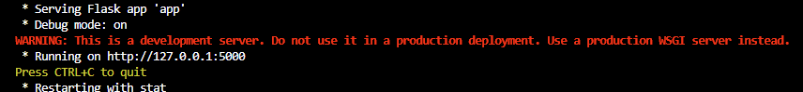

In this Example the system would be running on <http://127.0.0.1:5000> you can type this onto your desired browser or press control and click the link displayed.

1. To stop the server open the EC2 instance using PuTTY
   * inside the terminal run:

sudo pkill supervisord

* + then run:

sudo systemctl stop nginx

1. To turn the server on:
   * Navigate to Your Project Directory and Activate the Virtual Environment:

cd ~/python-education-system

source venv/bin/activate

* + Start Supervisor Daemon:

sudo /home/ec2-user/python-education-system/venv/bin/supervisord -c /etc/supervisord.conf

* + Check Status:

sudo /home/ec2-user/python-education-system/venv/bin/supervisorctl -c /etc/supervisord.conf status

* + Start Nginx:

sudo systemctl start nginx